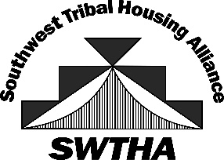

SOUTHWEST TRIBAL HOUSING ALLIANCE (SWTHA)
SCHOLARSHIP AWARDEES 2024

Bailon, Janine: Santo Domingo Pueblo, NM State University, Psychology
Beltran, Manuel: Ysleta Del Sur Pueblo, El Paso Comm. College, Criminal Justice
Clark, Rudolph: Hualapai Tribe, University New Mexico, Indian Law
Nez, Bailey: Navajo, Lawrence University, Environmental Sciences
Nez, Brooke: Navajo, Carthage College, Nursing
Salas, Matthew: Pueblo of Zia, University of New Mexico, Native American Studies
Talayumptewa, Latonya: Hopi Tribe, Grand Canyon University, Health Science

Thank you to AMERIND for providing the Region VIII Scholarship Funds!

swtha.org ~ swtha.region8@gmail.com

