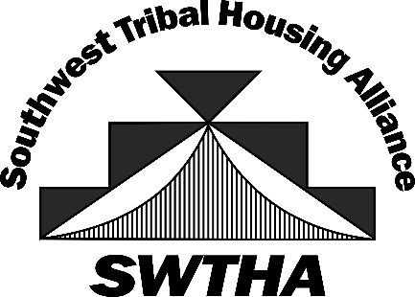
SWTHA Meeting and Training
September 17-19, 2024
Hon-Dah Resort and Casino
Pinetop, AZ

Sponsorship Opportunities
Gold Sponsor: $3,000
Silver Sponsor: $2,000
Bronze Sponsor: $1,000

Gold Sponsor:
- Two tickets to dinner
- Speaking time during dinner (20 minutes)
- Recognition at meeting, including name and logo on meeting printed program, posters, and flyers.
- Recognition on SWTHA website and newsletters, including logo and link.
Silver Sponsor:
- Speaking time during lunch (20 minutes)
- Recognition at meeting, including name and logo on meeting printed program, posters, and flyers.
- Recognition on SWTHA website and newsletters, including logo and link.
Bronze Sponsor:
- Recognition at meeting, including name and logo on meeting printed program, posters, and flyers.
- Recognition on SWTHA website and newsletters, including logo and link.

