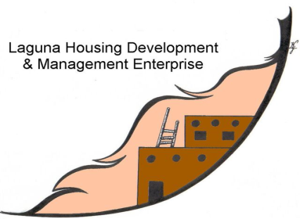
Job Vacancy Announcement

Position: Resident Services Specialist
Opening Date: September 9, 2024
Closing Date: September 23, 2024
Salary: DOE

Job Summary
Under the supervision of the Resident Services Director, this position provides guidance and instruction regarding home rental, home ownership and home renovation services. They will directly work with perspective and current tenants. Also conduct and coordinate tasks including public awareness, training sessions regarding financial budgeting and constant counseling. They will also perform monthly collections, track payments, recertifications of income, family composition, annual home inspections and other tasks to assist homebuyers and tenants who are under housing program agreements. Will make consistent visits to homebuyers homes and tenants rental units.

Essential Duties & Responsibilities
- Provides ongoing and post-occupancy counseling to current and prospective home buyers and rental tenants.
- Reviews and monitors tenant files for accuracy and completeness on an annual basis, or as needed.
- Ensures tenant compliance with lease agreements and LHDME’s policies.
- Communicates and educates current and prospective homebuyers/tenants on tenant responsibilities, home preventative maintenance, and safety awareness.
- Performs quarterly and annual home inspections for all LHDME managed units.
- Issues non-compliance reports for tenants not adhering to tenant responsibilities per LHDME policies and lease agreements.
- Communicates with tenants on a regular basis regarding housekeeping issues, income eligibility, home maintenance issues, and payments.
- Provides reports on occupancy and any related issues.

Knowledge, Skills & Abilities
- Must possess active listening skills to be empathetic to the different life situations of the tenants.
- Must be objective and possess good judgment decision making skills.
- Must possess proficient computer skills.
- Must possess excellent oral and written communication skills.
- Must be self-motivated.
- Must possess excellent time management skills.
- Must possess a working knowledge of HUD/NAHASDA policies and guidelines.

Minimum Qualifications
- Associates degree in Sociology, Property Management, Accounting or related field preferred.
- 3-5 years working experience directly related to the duties and responsibilities specified.
- Must have a valid NM driver’s license and be insurable.
- No felony convictions within the past ten years.
- Must be able to successfully pass a pre-employment drug/alcohol screen and background investigation.
- Job applicants may be subject to COVID-19 testing in the sole discretion of LHDME.
Work Environment
- Work is performed in a climate controlled office setting with a moderate noise level.
- Tight time constraints and multiple demands are common.
- Travel may be required for training, meetings, conferences, presentations, and other events.
On occasion may have to go out into the field (outdoors) to perform home inspections or meet with clients.
If interested in applying for this position, please submit application or resume to LHDME, Winona Bautista, Human Resources Dept., P.O. Box 178, Laguna, NM 87026; or email to:winonab@lagunahousing.org or fax to: 505-552-9409.
LHDME is an equal employment opportunity employer but does provide for Tribal/Indian Preference.

