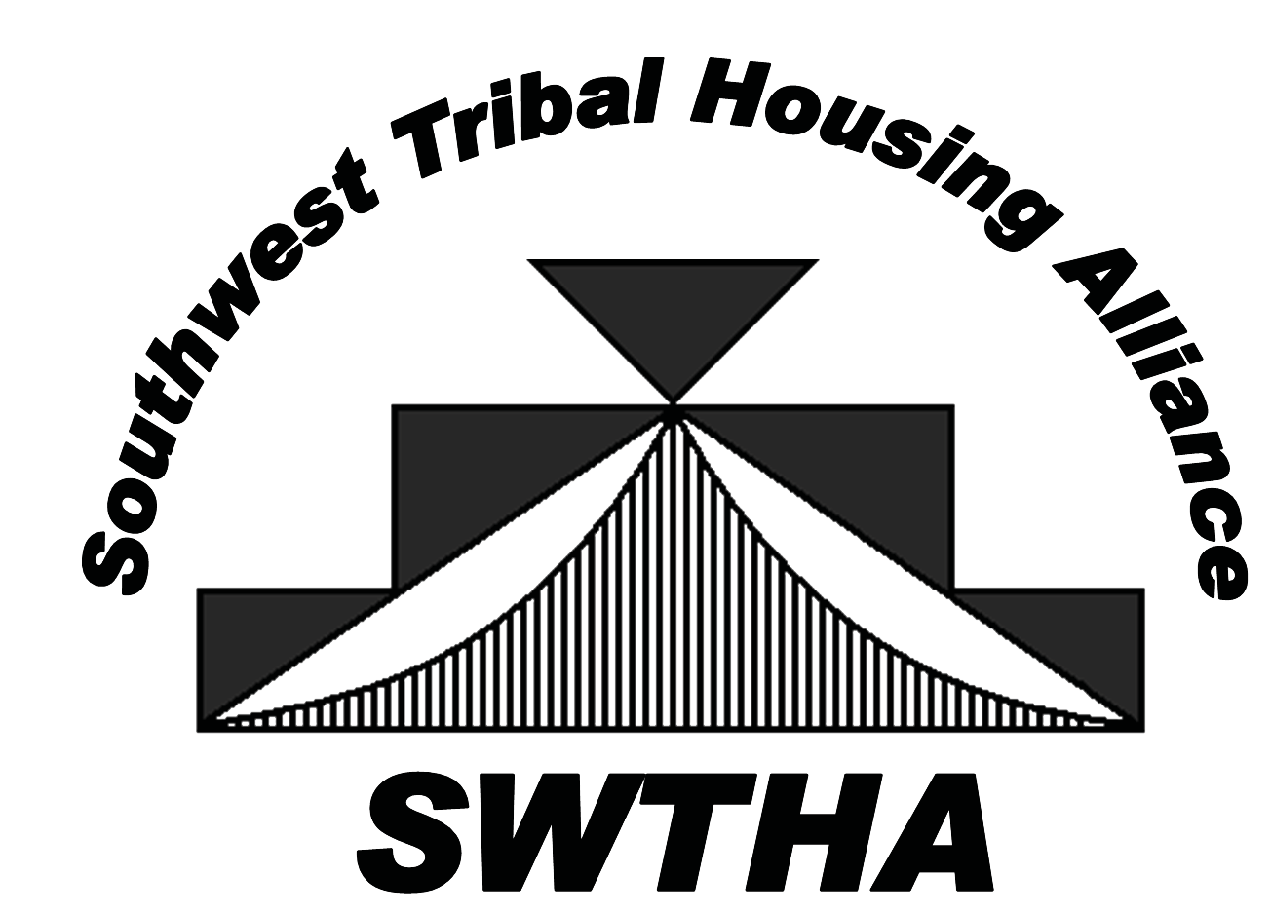

ESTABLISHED IN 2009, SWTHA is a relatively new

organization gaining strength and, as membership numbers increase, the strength of the alliance builds. Through the alliance, Tribal housing authorities support one another to ensure that unique Tribal housing needs and interests are recognized and addressed.

**Southwest Tribal Housing Alliance**

VISION: Region VIII Tribal Housing Advocate

MISSION: To be the voice for Tribal housing by providing relevant, timely information, resources and a valuable network for the SWTHA membership.

**Region VIII: Representing Arizona, New Mexico and West Texas—Tribes, Pueblos and Nations**

Reasons to Join: *SWTHA Membership Benefits*

■ More members mean a stronger voice for Native families.

■ A reasonable membership fee of only $250 per year.

■ Educational opportunities:

*> Technical training and assistance to increase administrative capacities.*

*> Access to regional and national speakers on regulatory compliance, development, finance, economic development, environmental, legal and other topics related to affordable housing.*

■ National and regional advocacy specifically for New Mexico,

Arizona and West Texas Tribal communities.

■ Scholarship opportunity:

> $10,000 awarded annually to the region sponsored by AMERIND Risk Management.

■ Triannual Membership Meetings and Trainings.

■ Strong partnerships with housing organizations such as

the National American Indian Housing Council.

“It is powerful to see the impact an alliance of devoted entities can make in a community. I have seen the members of the Southwest Tribal Housing Alliance do a tremendous job of representing Indian Housing Authorities, TDHEs and Tribes in providing a hand up to deserving families on tribal lands.”

**SWTHA Board Members & Representatives**

Lukaya Williams, Board Member

Arizona Representative

(928) 338-4831

lfall@wmaha.us

Thana Leslie, Board Member

Arizona Representative

(928) 737-2800

tleslie@htha.org

Greta Armijo,

Region VIII NAIHC Alternate Rep.

New Mexico Representative

(575) 834-0305

greta.armijo@pojha.org

**SWTHA Board of Directors**

Jamie Navenma, President

Region VIII NAIHC Representative

(505) 552-6430 jamien@lagunahousing.org

Francisco Carr, Vice President

(505) 552-7528 fcarr@acomahousing.org

Rhoda Eustace, Treasurer

Region VIII AMERIND Alternate Rep.

(505) 782-4550

reustace@pozha.org

Lorrie Chavez, Secretary

(505) 465-1003

LChavez@sdtha.org

# —Floyd Tortalita, SWTHA President and former Governor of Acoma

**Call, mail, email or visit us!**

[swtha.r](mailto:swtha.region8@gmail.com)[egion8@gmail.com](mailto:egion8@gmail.com) SWTHA.org

PO Box 10572

Albuquerque, NM 87184

Rachel Salas, Board Member

New Mexico Representative

(505) 219-5093

rachel.salas@ziapueblo.org

Martha Beltran, Board Member

West Texas Representative

(915) 859-9196

mbeltran@ydsp-nsn.gov

Veronica Ruiz,

Region VIII AMERIND Representative

(915) 859-9196

vruiz@ydsp-nsn.gov