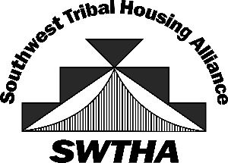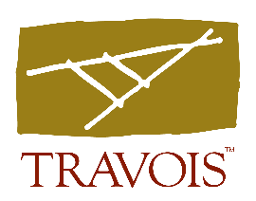

SWTHA Training – NSPIRE/HOTMA
January 29-30, 2025
9:00am – 5:00pm
Isleta Resort and Casino
Albuquerque, NM

Instructor: Crystal Banks Mann, Travois’ Client Engagement Manager

NSPIRE – January 29, 2025 (approx. 7 hr)
Effective Oct. 1, 2023, the National Standards for the Physical Inspection of Real Estate (NSPIRE) replaced HUD’s previous protocols (HQS, UPCS and REAC) for inspecting housing safety. Intended to align and consolidate the prior physical inspection regulations, NSPIRE focuses on three areas: the housing units where HUD assisted residents live, elements of their building’s non-residential interiors and the exteriors of buildings. NSPIRE scoring is focused on the health and safety of the housing units where residents live, as well as on the functional defects of buildings, and deemphasizes scoring based on the appearance of building exteriors. Knowledge of these new standards is essential for TDHEs to pass state and federal physical inspections.
- Changes to inspection protocol – we will dive into the reasons for the changes and the goals for the new standards.
- Scoring and self-monitoring – how best to score using HUD’s adjusted scoring methodology and the new self-monitoring requirements.
- Deficiency examples – in-depth analysis of each NSPIRE deficiency.
- Exam – optional exam to earn NSPIRE Inspection Specialist (NIS) designation.
HOTMA - January 30, 2025 (approx. 7 hr)
On July 29, 2016, the Housing Opportunity through Modernization Act of 2016 (HOTMA) was signed into law. HOTMA makes numerous amendments to Sections 3, 8 and 16 of the United States Housing Act of 1937, including significant changes to income and rent calculation, net family assets and required deductions. With HUD’s issuance of Notice PIH 2023-34, Tribal Nations and TDHE’s have until Jan. 1, 2025 to implement and come into compliance with the new Part 5 definition of “annual income” under the Indian Housing Block Grant (IHBG) program. During the session, we’ll discuss what this means to your organization’s policies and procedures. We’ll also cover HUD’s final rule implementing Sections 102, 103 and 104 of HOTMA.
Topics covered will include:
  - Asset limitation
  - Calculating income
  - Effective/compliance dates
  - Household composition
  - Income deduction, expenses and hardships
  - Income inclusion and exclusions
  - Interim reexaminations
  - Net family assets
  - Public housing over-income rules
  - Verification

